The Crayon Initiative

Do you have used or broken crayons around your house, especially right after school lets out for the summer? The UCC Green Team has decided to participate in a program called the Crayon Initiative (www.crayoninitiative.org) in cooperation with the Ames Public Library and Resource Recovery Center. Through this program, used (or new) crayons are collected, sorted by color and recycled into new crayons for donations to children’s hospitals.

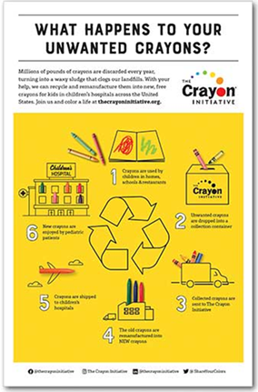
As explained on the Crayon Initiative website:
“Kids in hospitals are like children everywhere—they just want to be happy and play. We're here to help that happen, by giving them tools to make art. Studies show that art therapy can reduce heart rates, improve cognition, release endorphins and alleviate stress. And most of our young patients take our crayons home with them as the happiest part of their stay.”
There are more that 240 hospitals that are part of this network, including Blank Children’s Hospital and Mercy Children's Hospital in Des Moines and the University of Iowa Stead Family Children’s Hospital.
Ways that you can help:
• Bring your crayons to recycle to the Ames Public Library (children’s department)
• Bring your crayons to the Ames Resource Recovery Center (ARRC)
• Bring your crayons to Ames UCC and leave in the designated bucket across from the small kitchen – the Green Team will take them to the Library or ARRC.
If you have any questions or want to help, please contact any member of the Green Team.

